**Write a program which finds the real roots of quadratic equation. The formula for finding the roots of quadratic equations is given below:**

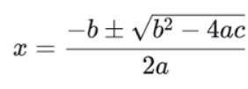

**Your program should fulfill following requirements:**

1. **Roots are real i.e.**
2. **square root of( b2-4*a*c) is greater than zero. Print message if roots are not real and then goto next iteration or exit if no more iteration.**
3. **Your program should not generate divide by zero error. Print Message if there is a divide by zero error and goto next iteration or exit if no more iteration.**
4. **Values for variables ‘a’, ‘b’ and ‘c’ are hard-coded in the program in a 2d array of size 3*3 such that you can atleast test the divide by zero error once and each data set should contain the values in the order of ‘a’ followed by ‘b’, and ‘b’ followed by ’c’.(3 marks).**

**HINT: For square root use: double Math.sqrt(double) built-in method.**